All about the p53, TP53, DCIS, IDC, and BRCA: -
Ductile carcinoma in situ (DCIS)

Invasive ductile carcinoma

Invasive breast carcinoma
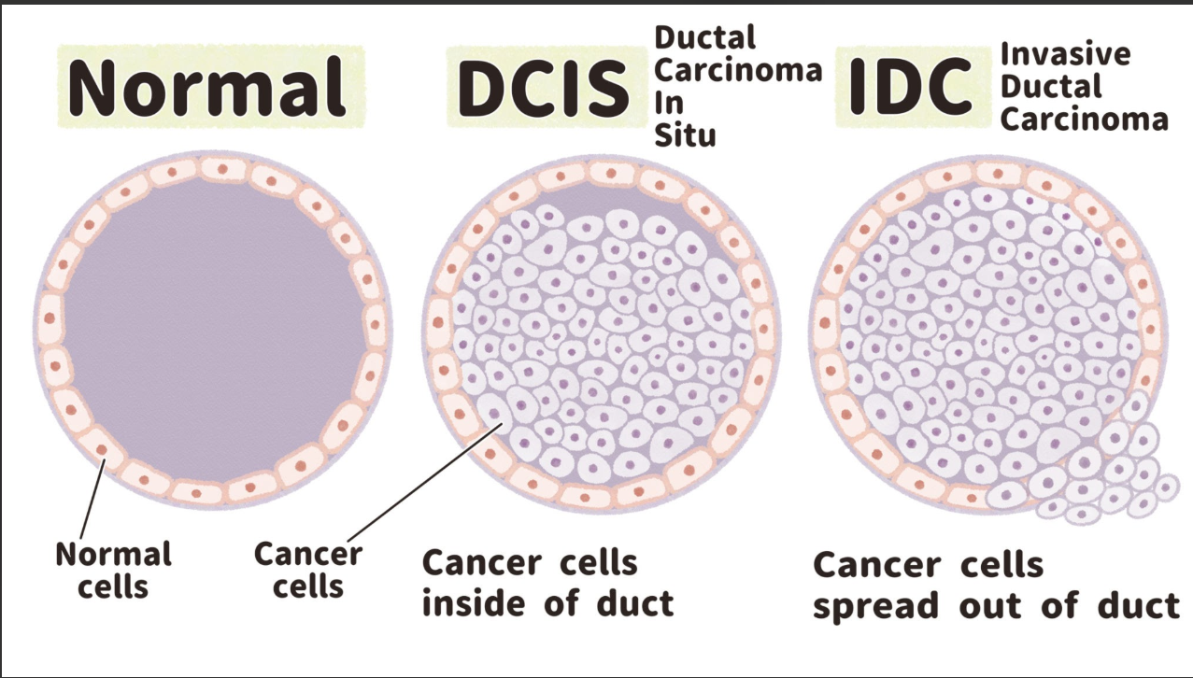

So basically, the p53 is known as the “Guardian of the Genome” because it is the gene inspector that takes care of the replication of only the right kind of cells. The characteristics of these cells is specified under the “genetic instruction manual” called TP53. When this manual gets affected like either its smudged or affected somehow, the p53 becomes inactive. The wrong kind of cells start multiplying themselves at a very rapid pace.

The Molecular Architecture: Normal Mammary Ducts
In healthy breast tissue, the milk ducts are hollow pipes built from an inner layer of luminal epithelial cells surrounded by specialized contractile myoepithelial cells, all wrapped inside a physical barrier called the basement membrane (composed of Type IV collagen and laminin).
The Normal Molecular Mechanism going on inside of cells at all times: -
- The p53 has to be in standby in case any emergency arises but if its there at high concentration around the cells at all times then it sort of acts as the self-destruct button at destroys the healthy cells as well. So, to prevent self-destruction of cells the p53 is constantly made and destroyed every 15-20 minutes. An E3 ubiquitin Ligase called MDM2 is constantly attaching ubiquitin to the formed p53 so that the proteosome breaks it down.
- When due to uv rays chemicals and some DNA copying defects the DNA breaks or is damaged, the senior kinases called ATM /ATR sitting on DNA detect those broken end and signal about this breach (sort of like sounding an alarm).
- After the DNA snaps the phosphorylate groups which are bulky negatively charged groups attach themselves to the spots names serine15 and serine20.
- Because of this big bulky tag, MDM2 (the bodyguard) can no longer grab p53. Its grip slips right off.
- The p53 levels shoot through the roof and the DNA is stabilized.
- A lone p53 molecule is weak. To actually grab onto DNA and turn on genes, four p53 molecules must click together like four matching puzzle pieces.
- "Homotetramer" just means:
Homo = same (four identical p53s)
Tetra = four
Mer = parts
- Once the 4-part squad snaps together, it marches into the control room (the nucleus), sits directly down on the DNA, and starts reading the commands to hit the brakes on cell division.
- This 4-squad of p53 takes life or death decisions for the cell.
- If the broken fragment can be patched, they call p21 protein that works as a handbrake to stop the DNA replication process by stopping the action of cyclin dependent kinases(cdks) that help to knockout the action if the retinoblastoma protein(rb), that is responsible for guarding the nuclear membrane so that outer substances don’t enter inside the nucleus.
- This p21 protein is released when the p53 attaches to the CDK1A.
- Due to this the cell division is arrested in the G1/S phase. Now the factors like GADD45 are recruited to summon repair enzymes to fix the DNA.
- If the cell is not fixable then, the p53 produces BAX, PUMA, AND NOXA.
- These then go into the mitochondria and make the outer membrane of the mitochondria perforated.
- Due to this the cytochrome c pigment leaches out of the mitochondria into the cytoplasm.
- This starts the caspase cascade: - It wakes up or activates the enzyme Caspase-9 which in turn triggers Caspase-3 which slices the chromosomes and packages the
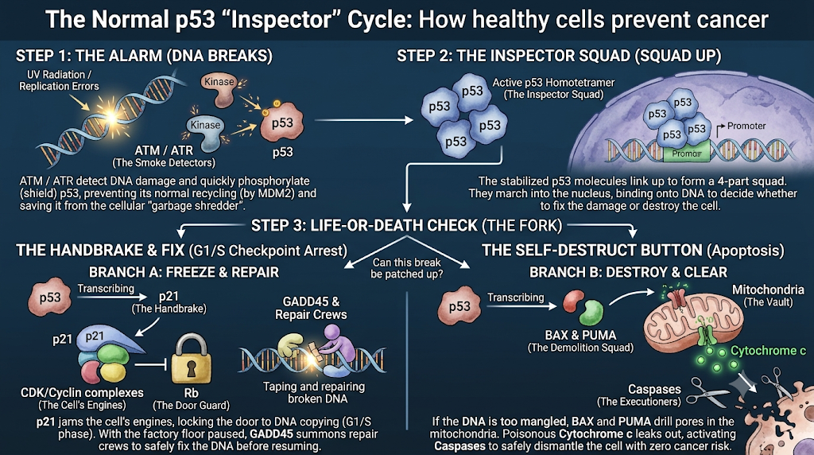
entire cell into a little package that is in turn engulfed by the neighboring cells without leaving any residue or causing any inflammation at all.

HOW THE MUTATED TP53 GENE TRANSFORMS THE NORMAL MILK DUCT INTO INVASIVE DUCTAL CARCINOMA?
- Location of the TP53 gene: Chromosome 17p13: The cell's library has 23 pairs of giant file cabinets (chromosomes). Cabinet #17, top shelf (the "p" arm), folder 13 is where the instruction manual for building the Inspector (TP53) is kept.
- Due to the TP53 gene mutation the inspector doesn’t regulate the process anymore due to which unchecked cell division occurs forming irregular cells that fill up the space inside the lumen completely.
- After sometime the dead cells present at the dead center of the duct are pushed too far away from the blood vessels due to this, they become completely deprived of oxygen and nutrients and start necrotizing.
- This stage when viewed under the microscope resembles the center of a comedone or pimple hence it called as “comedo necrosis”.
- But at this stage the outer wall of the duct is still intact the cells haven’t spread outside and affected other organs that’s why it is called in-situ.
- To show its invasive action it has to dissolve the leathery thick fence which is the basement membrane and go into the fatty fibrous tissue called stroma. This is achieved by two criminal operations pulled off by the p53 (Mutant).
- Mechanism A: Missense mutation has occurred in the “DNA-binding domain “of TP53. Due to this the codons R175, R248, R273 are modified in the transcribed mRNA .so when the p53 protein is formed it has different set of amino acids that alter its functioning. There are two ways by which this mutation wrecks the remaining good proteins that are being formed: -
- Tetramer poisoning: - to sit on DNA, four p53 units must snap together into a squad, if three healthy inspectors link arms with just one deformed mutant, the whole 4-man squad is ruined. The deformed claw throws off the grip of the entire group. They cannot grab the DNA handrail. this is called: "dominant-negative"—the bad copy poisons the good copy.
- Loss of Heterozygosity: Eventually, the chaotic cell accidentally snaps or deletes the normal backup gene on chromosome 17 entirely. zero good inspectors being made. Without any surveillance, the cell's genetic code descends into total anarchy: whole chromosomes get shattered, swapped, or multiplied (severe aneuploidy and translocations).
- Mechanism B: The "Oncomorphic" Conversion, Broken p53 doesn't just disappear. Because its shape is deformed, the cleanup bodyguard (MDM2) can’t grab it, deformed p53 builds up in huge piles inside the nucleus. this mutant protein isn't just sitting there—it has Gained New Functions (Oncomorphic / Cancer-forming powers). It actively helps the tumor break out. There are three ways in which this is done:
- Kidnapping the cousins:
P53 has two sibling transcriptor factors called p63 and p73.so when the p53 is absent the p63 and p73 try to step up and stop the cancer form spreading but eventually the very high amounts of mutant p53 prevents them from suppressing metastasis.it basically, physically grabs them.
- EMT (Epithelial-to-Mesenchymal Transition):
Normally the duct cells are glued together by E-cadherin. But the p53 teams up with three genetic switch boards

